

**ASSIGNMENT 2:**

Submitted by: Syed Ali Naqi

ROLL# 466889

Section: ME-15B

Date: 11Oct,2023.

**COMPUTER SCIENCE AND PROGRAMMING**

**Task#1:**

#include<iostream>

#include<cmath>

using namespace std;

int main(){

int y;

cin>>y;

if(90<=y&&y>=100){

cout<<"your grade is A*";

}

else if(75<=y&&90>y){

cout<<"your grade is B*";

}

else if(60<=y&&75>y){

cout<<"your grade is B";

}

else if(45<=y&&60>y){

cout<<"your grade is C";

}

else{

cout<<"your grade is D";

}

return 0;

}

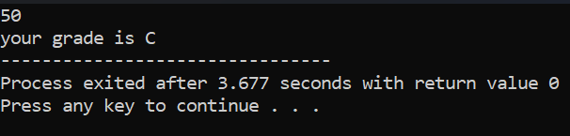

**Task#2:**

#include<iostream>

using namespace std;

int main(){

int r;

cout<<“ enter the integer: ”;

cin>>r;

if(r/2&&r/5){

cout<<“the integer is divisible by 2 and 5”;

}

else{

cout<<“your integer is not divisible by 2 and 5”;

}

return 0;}

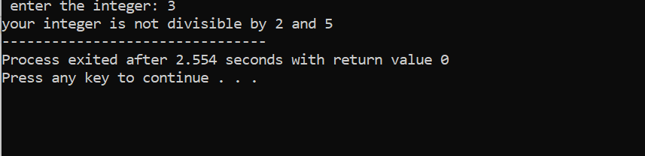

**Task#3:**

#include<iostream>

#include<cmath>

using namespace std;

int main(){

int b;

cout<< " Enter the year: ";

cin>>b;

if( b%4==0 && b%100!=0){

cout<< " the year is a leap year";}

else {cout<<" the year is not a leap year";}

return 0;}

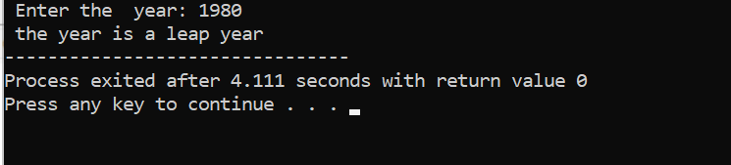

**Task#4:**

#include<iostream>

#include<cmath>

using namespace std;

int main(){

float x;

float y;

cout<<" Enter the GPA: ";

cin>> x;

cout<< " Enter the attendance percentage: ";

cin>> y;

if( x>= 3.5 && y>=80){ {

cout<<" Student is eligible for scholarship";}

else { cout<<" Student is not eligible for scholarship"; }

return 0; }

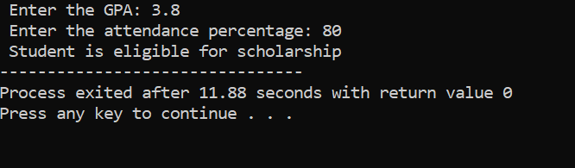

**Task#5:**

#include<iostream>

#include<cmath>

using namespace std;

int main(){

char z;

cout<< “ Enter the character: ";

cin>>z;

if ( z=='a'||z=='e'||z=='i'||z=='o'||z=='u'){

cout<< " The entered character is a vowel";}

else { cout<< " The entered character is a consonant";}

return 0;}

